**【聚焦全民国家安全教育日】全民国家安全教育日，一起来学习！**

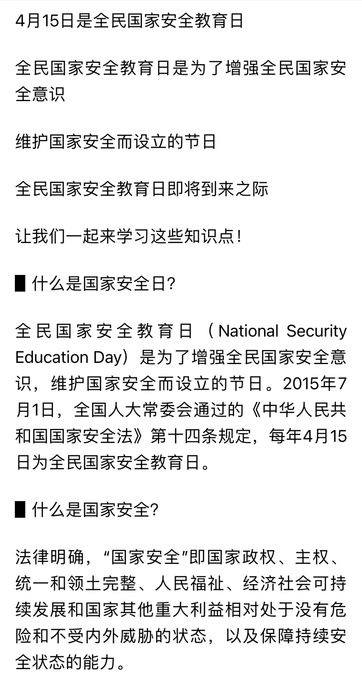

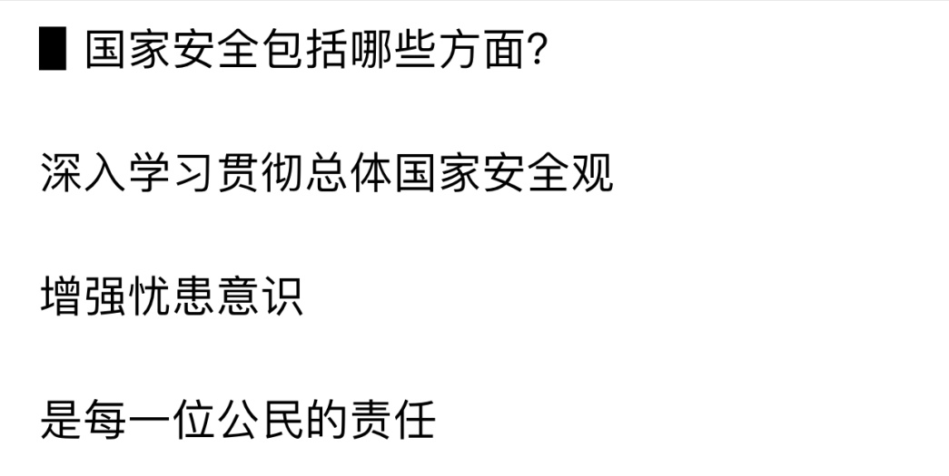

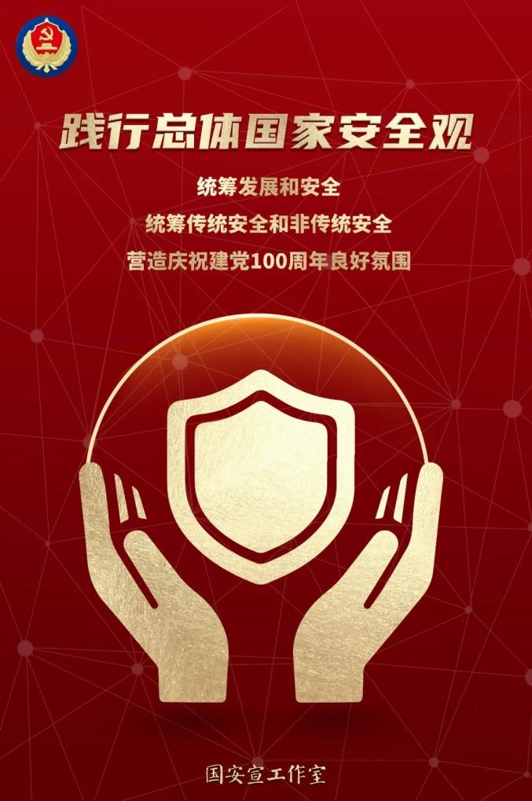

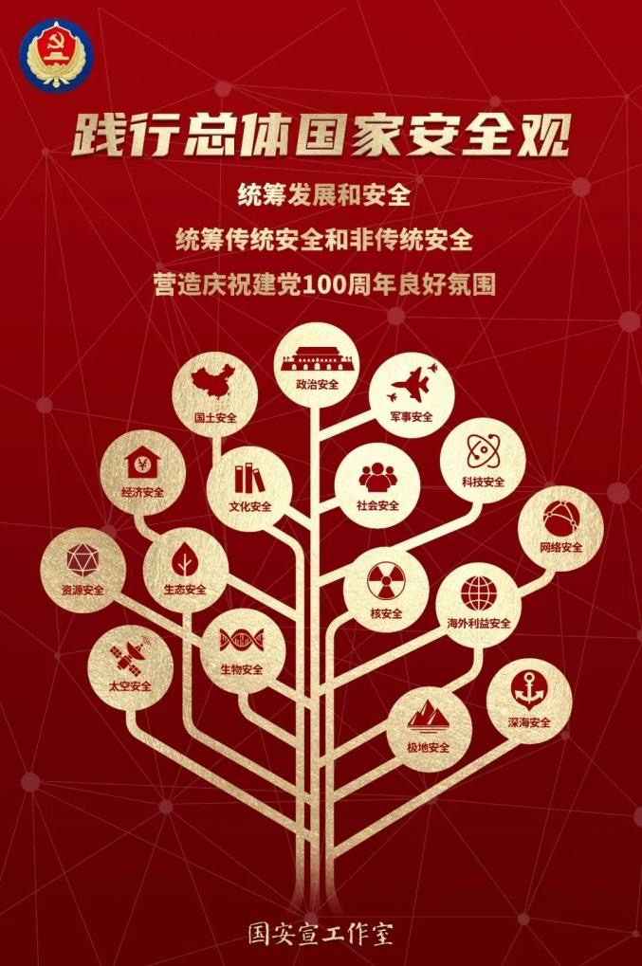

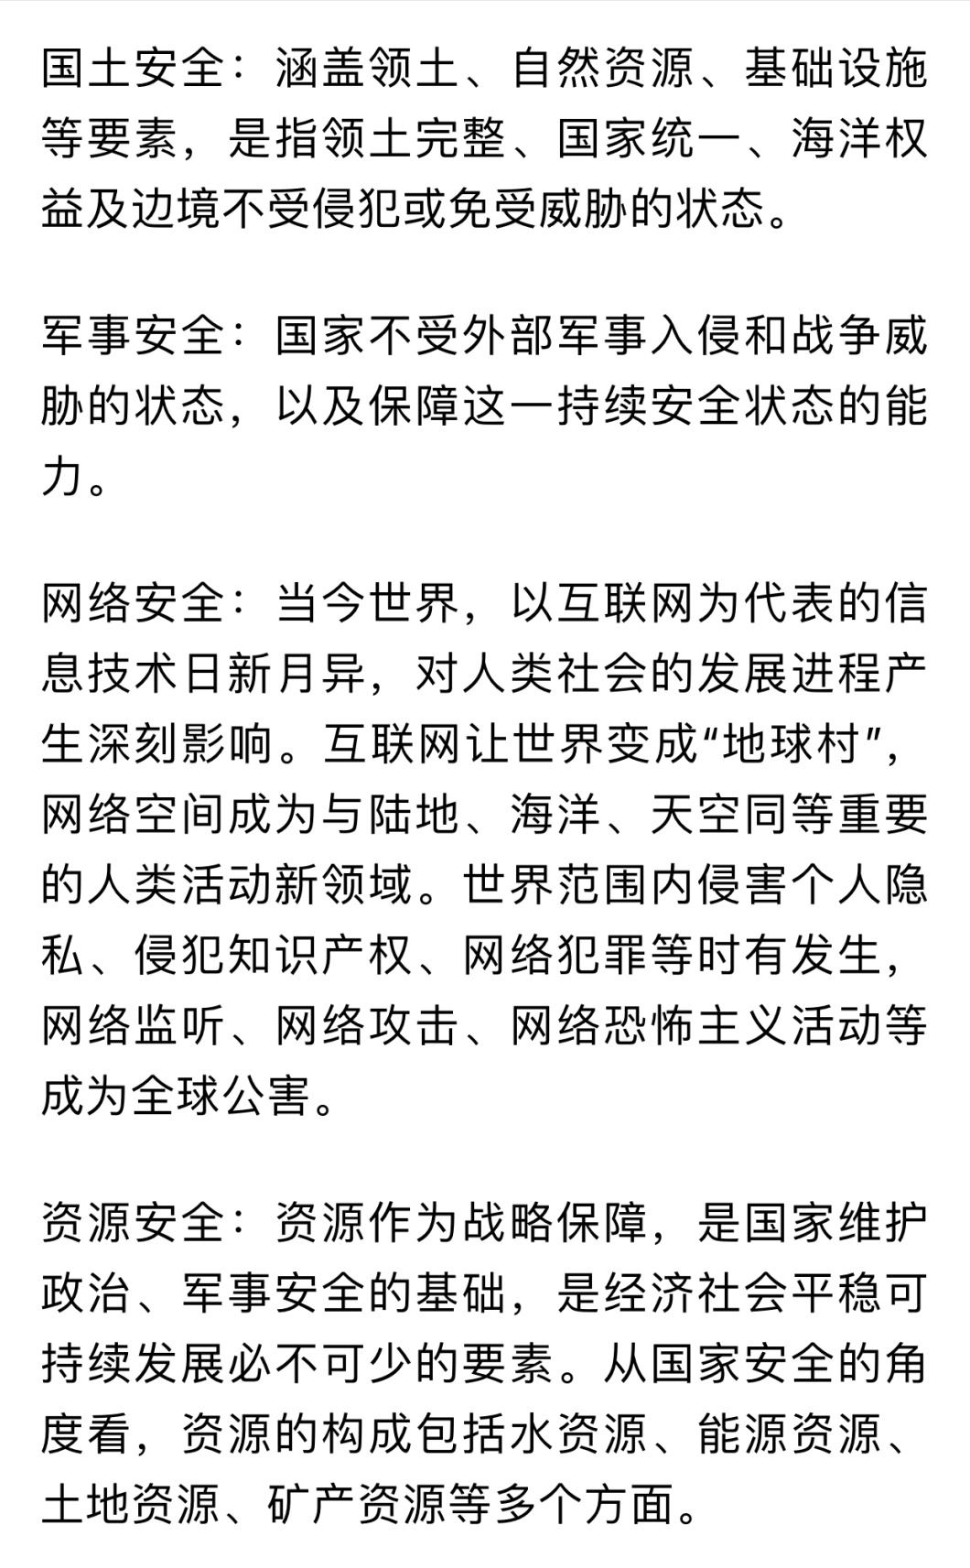

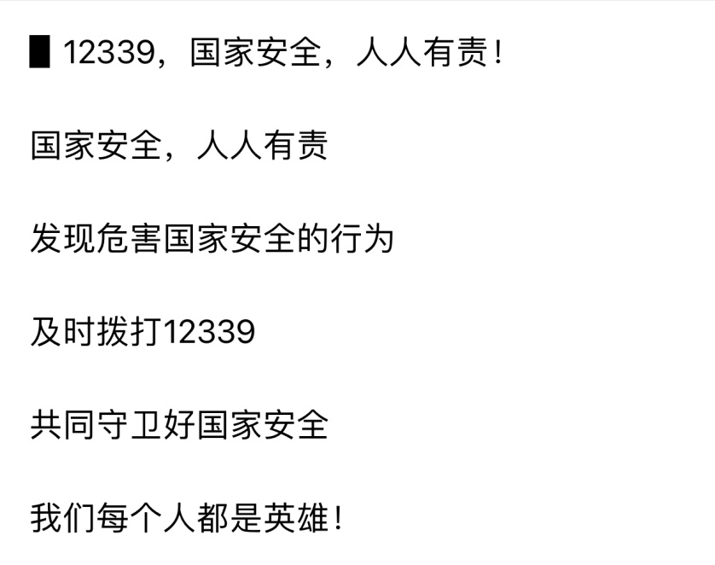



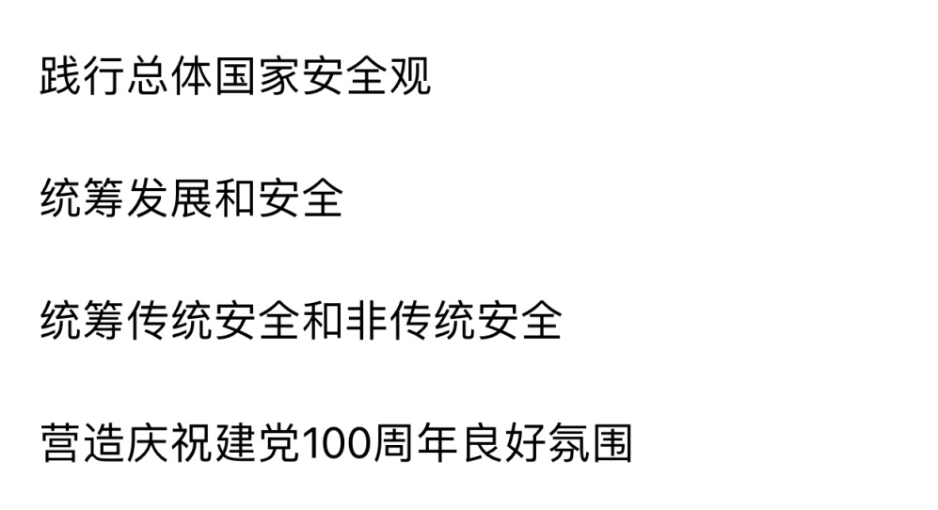

    点击链接，观看视频：<https://m.baidu.com/video/page?pd=video_page&nid=3755131732273210561&sign=9168157441352072493&word=2021%E5%B9%B4%E5%9B%BD%E5%AE%B6%E5%AE%89%E5%85%A8%E6%97%A5&oword=2021%E5%B9%B4%E5%9B%BD%E5%AE%B6%E5%AE%89%E5%85%A8%E6%97%A5&atn=index&frsrcid=5377&ext=%7B%22jsy%22%3A1%7D&top=%7B%22sfhs%22%3A1%2C%22_hold%22%3A2%7D&sl=4&trace=10953940062619840291&isBdboxShare=1&_t=1618467312996>